Data Analysis

_{Project: Amazon Sales Analysis}
Introduction:
This project focuses on E-Commerce Data Analysis to understand customer behavior, product performance, sales trends, and payment patterns. By analyzing data related to orders, products, shipping, payments, and promotions the project helps businesses make better data-driven decisions and improve overall performance.
Objective:
The objective of this data analysis project is to analyze Amazon sales order data to gain insights into order status, product performance, shipping behavior, payment trends, and promotional impact.
This analysis helps in understanding sales performance, customer demand, logistics efficiency, and revenue generation, enabling better business and operational decision-making.
Scope of the Project:
Identify best-selling and slow-moving product. Analyze payment methods and transaction status. Study monthly and yearly sales trends Perform city-wise and shipping performance analysis.
Data Cleaning:
Missing values were handled using Python. Invalid data types were corrected, duplicates removed, and foreign key mappings applied.

Tools and Technologies Used:
- MySQL – for storing, querying data and analysis.
- Python – for data analysis and visualization.
Pandas & Matplotlib – for data processing and charts, plots, graphs.
- PowerPoint – for data presentation and reporting.
- MS Excel
- Draw.io

Analyses Based on Available Tables:
Order Analysis (orders table)
● Analyze total number of orders.
● Analyze order distribution based on order status (Shipped, Delivered, Cancelled, and Pending).
● Analyze fulfillment methods (Amazon / Merchant).
● Identify orders based on sales channel and service level.
Product Analysis (products table)
● Identify total number of products sold category-wise.
● Analyze product distribution based on size and style.
● Identify most frequently sold products using SKU and ASIN.
● Analyze sales contribution by product category.
Payment & Sales Analysis (payments table)
● Calculate total revenue generated from all orders.
● Analyze revenue order-wise and product-wise.
● Identify high-value and low-value orders.
● Analyze quantity sold across different products.
● Analyze sales performance based on currency and amount.
Shipping & Logistics Analysis (shipping table)
● Analyze shipment distribution city-wise and state-wise.
● Identify countries with maximum shipments.
● Analyze courier status and delivery performance.
● Identify regions with higher order volume.
Promotion Analysis (promotions table)
● Analyze the impact of promotions on sales.
● Identify orders with and without promotions.
● Analyze promotion usage across different sales channels.
● Compare sales performance for promoted vs. non-promoted orders.
Geographical Analysis
● Explore order distribution across different cities and states.
● Identify high-demand regions based on order volume.
● Analyze shipping trends by location.
Time-Based Analysis
(Using Date column from orders table)
● Analyze date-wise sales trends.
● Identify peak order dates.
● Analyze order volume trends over time.
Overall Business Insights
● Identify top-performing products and categories.
● Analyze sales and revenue growth patterns.
● Evaluate logistics efficiency and shipping performance.
● Understand customer demand across regions.
● Assess promotional effectiveness on sales performance.
SQL Analysis
SQL queries were used to analyze customer behavior, product performance, order status, sales trends, payment transactions, and shipping details. The analysis helped identify total orders, best-selling and slow-moving products, revenue contribution by category, preferred payment methods, repeat customers, and geographical sales patterns across different cities. This provided a clear understanding of overall business performance and customer purchasing trends.
Dataset Overview:
The dataset consists of three main tables:
Payments: Contains information about Qty, currency, Amount.
CREATE TABLE payments (
Payment_id INT AUTO_INCREMENT PRIMARY KEY,
Order_id BIGINT,
Qty INT,
Currency VARCHAR (5),
Amount DECIMAL (20, 2)
);

Orders: Contains information about index, Order ID, Date, Status, Fulfillment, Sales Channel, ship_service_level, Style, promotion_ids, B2B, fulfilled_by.
CREATE TABLE orders (
Order_id BIGINT PRIMARY KEY,
Index1 INT,
Date VARCHAR (50),
Status VARCHAR (100),
Fulfillment VARCHAR (50),
Sales_channel VARCHAR (50),
Ship_service_level VARCHAR (100),
Style VARCHAR (50),
Promotion_ids VARCHAR (3500),
B2b BOOLEAN,
Fulfilled_by VARCHAR (50)
);

Products: Contains information about SKU, Category, Size, ASIN and Style
CREATE TABLE promotions(
promotion_id INT AUTO_INCREMENT PRIMARY KEY,
order_id BIGINT,
sales_channel VARCHAR(50),
promotion_ids VARCHAR(3500)
);

Step to be performed:
Database Connectivity: This project focuses on E-Commerce Data Analysis to understand customer behavior, product performance, sales trends, and payment patterns. By analyzing data related to customers, orders, products, shipping, and payments, the project helps businesses make better data-driven decisions and improve overall performance.
# Example Python code for connecting to MySQL database using
mysql-connector-python
import mysql. Connector
import pandas as pd
import numpy as np
# Replace 'your_username', 'your_password', 'your_host', and 'your_database' with actual credentials
connection = mysql.connector.connect (
host="localhost",
user="root",
password="1234",
database="students_course_analysis"
)
# Create a cursor object to execute SQL queries
cursor = connection. cursor ()
# Query data from the 'payments' table
insert_sql = """
INSERT IGNORE INTO payments (order_id, qty, currency, amount)
VALUES (%s, %s, %s, %s)
"""

.

# Query data from the 'orders' table
orders_sql = """
INSERT INTO ORDERS
(order_id,index1,Date,status,fulfilment,sales_channel,ship_service_level,style,promotion_ids,b2b,fulfilled_by)
VALUES (%s, %s, %s, %s, %s, %s,%s, %s, %s, %s,%s)
"""
# Query data from the 'products' table
insert_sql = """
INSERT INTO products (order_id, sku, size, asin, style, category)
VALUES (%s, %s, %s, %s, %s, %s)
"""

Python Analysis Python was used for advanced aggregations, visualizations, and exporting clean datasets for Power BI and Excel usage. 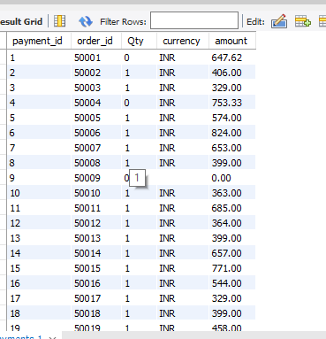
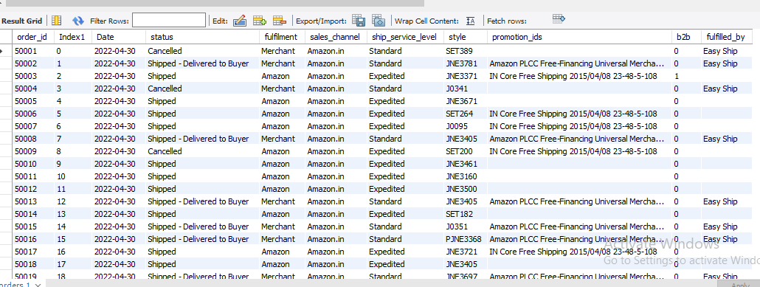

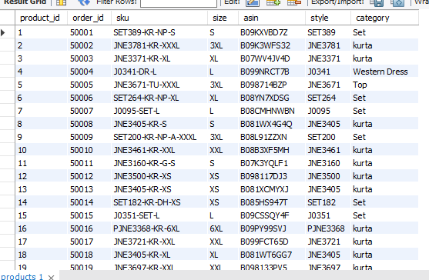
Description:
orders_df = pd.read_csv ("C:\\Users\\FAZAL\\Documents\\Final Project\\Amazon Sale Analysis\\Orders.csv")
pd.DataFrame (...): This part creates a Pandas Data Frame using the pd.DataFrame () constructor. It takes the fetched data (result of the query) and the list of column names as arguments. The Data Frame is assigned to the variable orders.
In summary, this line of code fetches data from a database using a cursor, extracts column names from the cursor description, and creates a Pandas Data Frame with the fetched data and column names. The resulting Data Frame can be used for further analysis or manipulation using Pandas functionalities.
Data Cleaning:
Before proceeding with the analysis, let's perform some basic data cleaning:
● Check for missing values in each table.
● Ensure data types are appropriate for each column.
● Handle any outliers or in consistencies.
● Identify best-selling and slow-moving products
● Evaluate sales, revenue, and profitability
● Analyze payment methods and transaction status
Exploratory Data Analysis (EDA) and Visualization: Analysis of Orders Status Wise by Total Orders.
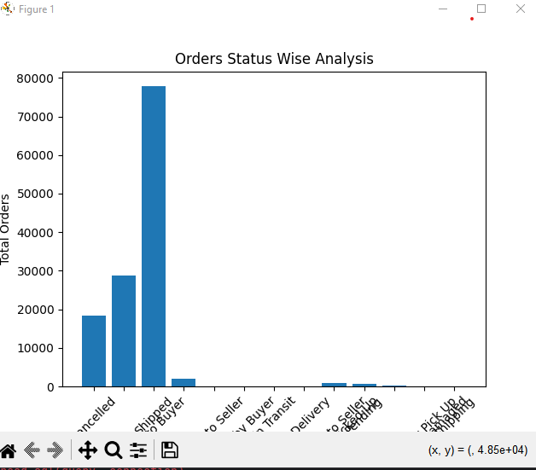
Analysis of Fulfillment Type Distribution
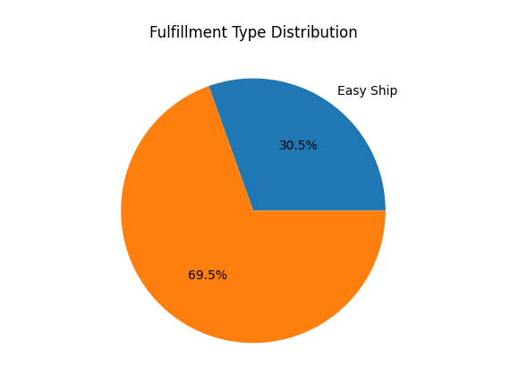
Analysis of Category Wise Products
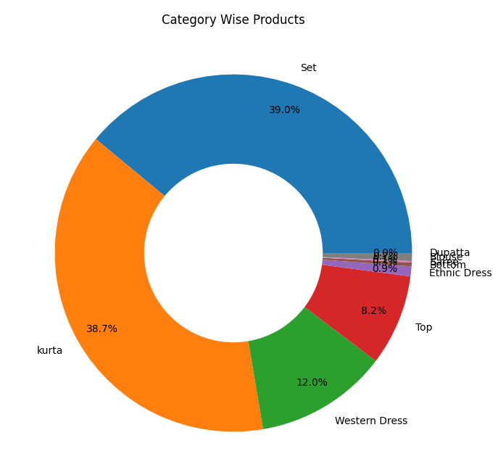
Analysis of Category Wise Products by Size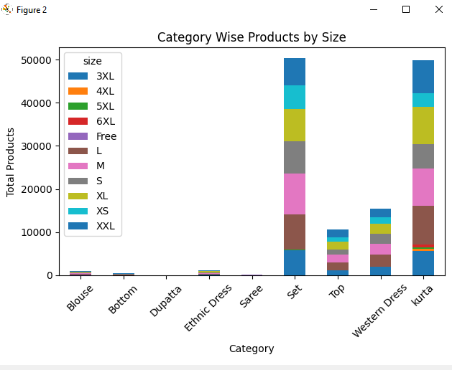
Analysis of Size Wise Sales
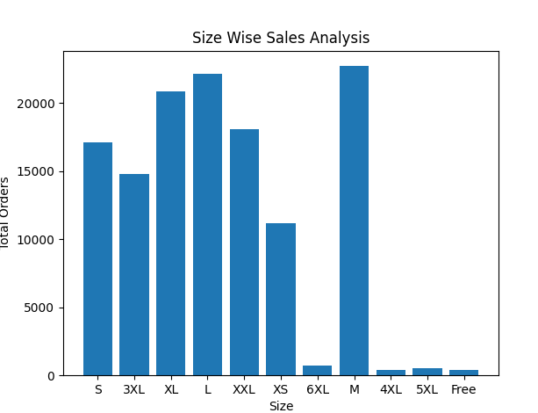
Analysis of Courier Status Distribution
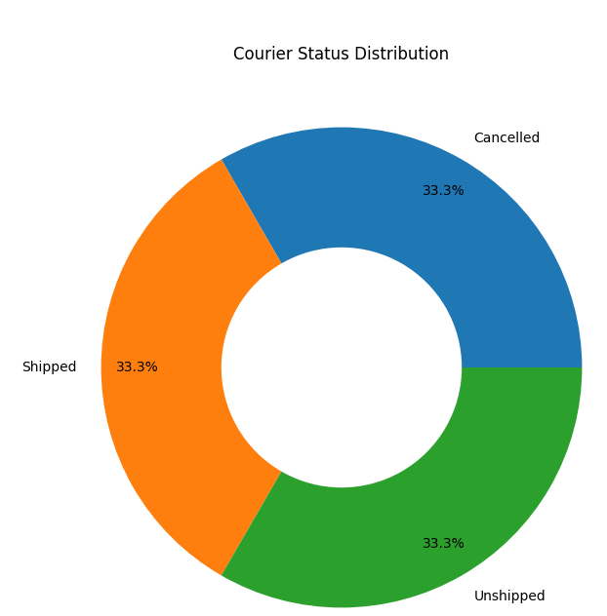
Analysis of City Wise Orders by Courier Status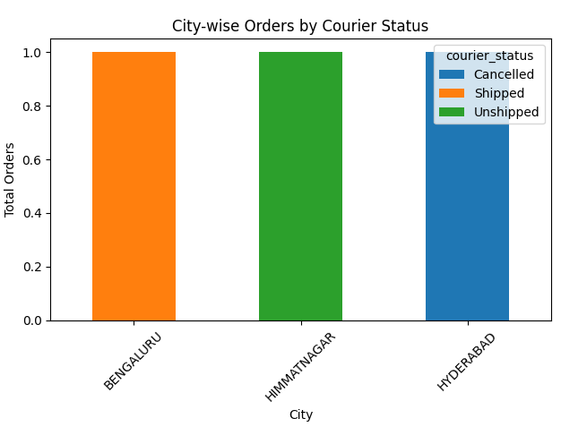
Analysis of Promotion Impact on Orders
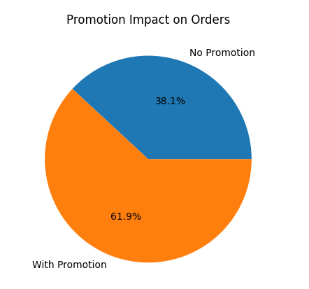
Analysis of Monthly Orders Trend
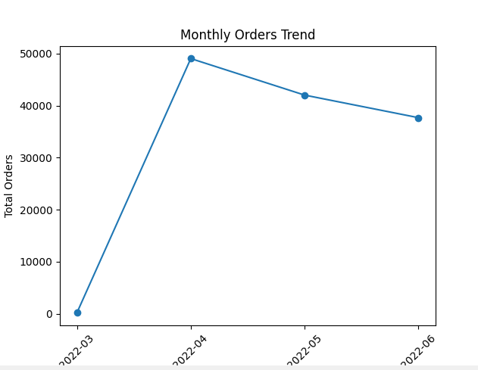
Analysis of Monthly Orders Trend

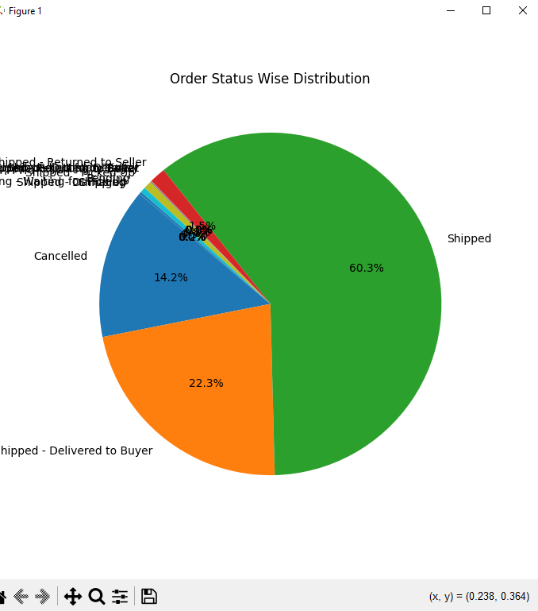
ER Diagram: The ER diagram represents the relationship between orders, products, promotions, payments, and shipping details in the e-commerce system. It shows how customers place orders, how orders are linked to products, and how payment and shipping information is associated with each order. The diagram helps in clearly understanding the database structure, relationships between entities, and the overall flow of data in the system.
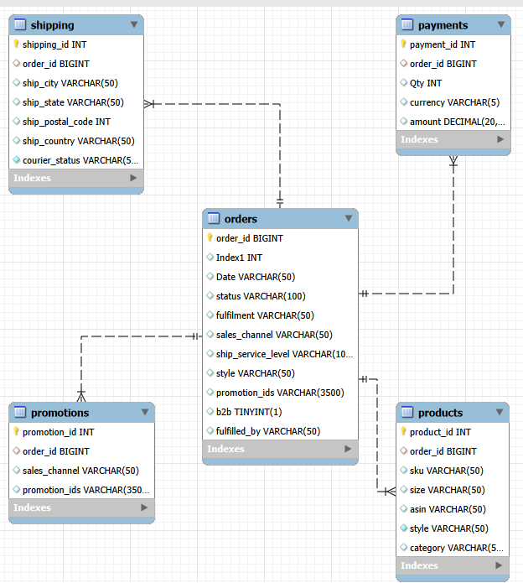
Power BI Dashboard
Interactive dashboards were created including KPIs, slicers, orders analysis, payments performance, and products insights.
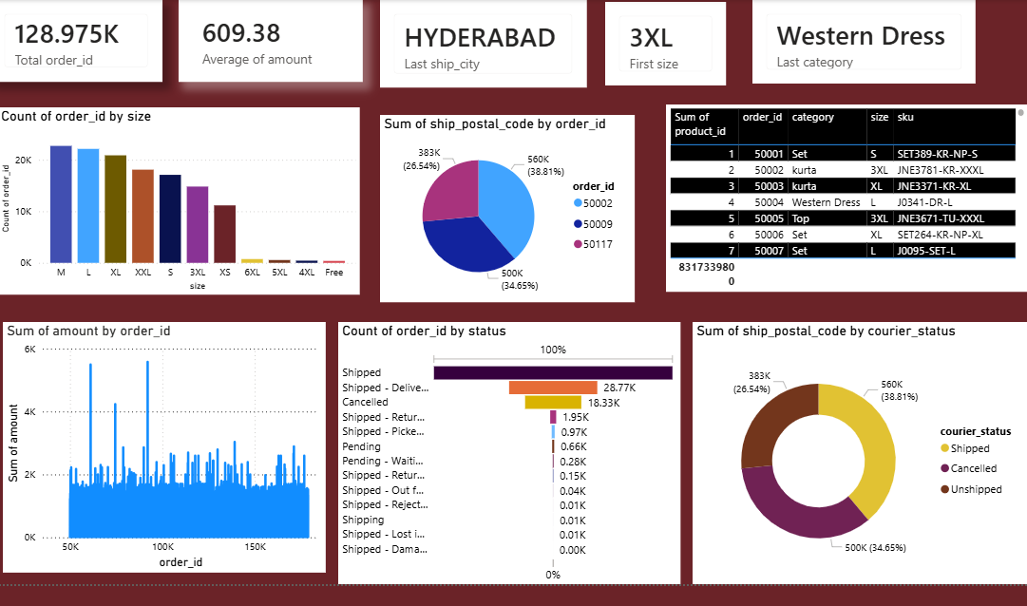
Conclusion: The E-Commerce Data Analysis project provides valuable insights into customer behavior, product performance, sales trends, and payment patterns. The analysis helps in understanding overall business performance, identifying best-selling and slow-moving products, and improving decision-making related to inventory management, marketing, and customer retention.
Future Work / Enhancements:
In the future, additional parameters such as customer reviews, product ratings, and delivery time performance can be added to the dataset. Advanced analytics and interactive dashboards can be implemented for better data visualization. Predictive analysis can also be applied to forecast sales trends, identify high-value customers, and optimize inventory planning.

